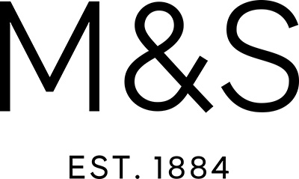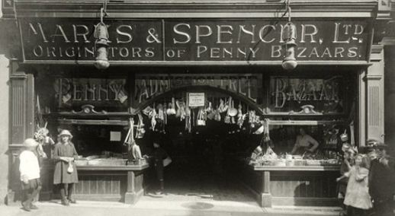

**MARKS & SPENCER**

### http://static.guim.co.uk/Guardian/business/gallery/2008/jul/09/marksandspencer.history/marks-8229.jpg

### Establishment

The company was founded by a ________________________________ (PARTNER) between [Michael Marks](http://en.wikipedia.org/wiki/Michael_Marks), a [Belarusian Jew](http://en.wikipedia.org/wiki/History_of_the_Jews_in_Belarus) (Marks was born into a Polish-Jewish family, a Polish refugee living in the Russian Empire (now in [Belarus](http://en.wikipedia.org/wiki/Belarus))), and [Thomas Spencer](http://en.wikipedia.org/wiki/Thomas_Spencer_(Marks_and_Spencer)), a _________________________________ (CASH) from the English market town of [Skipton](http://en.wikipedia.org/wiki/Skipton) in [North Yorkshire](http://en.wikipedia.org/wiki/North_Yorkshire).

On his _______________________________ (ARRIVE) in England, Marks worked for a company in Leeds, called Barran. In 1884 he met Isaac Jowitt Dewhirst while looking for work. Dewhirst lent Marks £5 which he used to establish his Penny Bazaar on [Kirkgate Market](http://en.wikipedia.org/wiki/Leeds_Kirkgate_Market), in Leeds. Dewhirst also taught him a little English. He met Tom Spencer, who was Dewhirts’s excellent ____________________________ (BOOK). His ____________________________ (LIVE) and intelligent second wife, Agnes, helped improve Marks' English. In 1894, when Marks acquired a _____________________________ (PERMANENCE) stall in Leeds' covered market, he invited Spencer to become his partner.

In 1901 Marks moved to the [Birkenhead](http://en.wikipedia.org/wiki/Birkenhead) open market where he amalgamated with Spencer. The pair were allocated stall numbers 11 & 12 in the centre aisle in 1903, and there they opened the ____________________________ (FAME) Penny Bazaar. The company left Birkenhead Market on 24 February 1923.

The next few years saw Michael Marks and Tom Spencer open market stalls in many ___________________________ (LOCATE) around the North West of England and move the original Leeds Penny Bazaar to [Manchester](http://en.wikipedia.org/wiki/Manchester).

### Domestic growth

Marks and Spencer, known _________________________ (FORMAL) as "Marks and Sparks", or "M&S", made its reputation in the early 20th century with a policy of only selling British-made goods. It entered into long term relationships with British __________________________ (MANUFACTURE), and sold clothes and food under the "[St Michael](http://en.wikipedia.org/wiki/St_Michael_(brand))" brand, which was ____________________________ (INTRODUCTION) in 1928. The brand honours [Michael Marks](http://en.wikipedia.org/wiki/Michael_Marks). It also accepted the return of unwanted items, giving a full cash refund if the receipt was shown, no matter how long ago the product was purchased, which was unusual for the time.

By 1950, _____________________________ (VIRTUAL) all goods were sold under the "St Michael" label. M&S lingerie, women's clothes and girls' school uniform were branded under the "St Margaret" label until the whole range of general merchandise became "St Michael".

[Simon Marks](http://en.wikipedia.org/wiki/Simon_Marks), son of Michael Marks, died in 1964, after fifty-six years' service. [Israel Sieff](http://en.wikipedia.org/wiki/Israel_Sieff), the son-in-law of Michael Marks, took over as _______________________________ (CHAIR) and in 1968, [John Salisse](http://en.wikipedia.org/wiki/John_Salisse) became the company Director. A cautious international _________________________________ (GROW) began with the introduction of Asian food in 1974. M&S opened stores in _______________________________ (CONTINENT) Europe in 1975 and in Ireland four years later.

The company put its main _____________________________ (EMPHASISE) on quality, including a 1957 stocking size measuring system. For most of its history it also had a reputation for offering fair value for money. When this reputation

began to waver, it encountered some serious ____________________________ (DIFFICULT). Arguably, M&S has __________________________ (HISTORY) been an iconic retailer of 'British Quality Goods'.

The uncompromising attitude towards customer relations was ___________________________ (SUMMARY) by the 1953 slogan: "The customer *is* always and completely right!"

Energy __________________________ (EFFICIENT) was improved by the addition of thermostatically controlled refrigerators in 1963.

M&S began selling [Christmas cakes](http://en.wikipedia.org/wiki/Christmas_cake) and [Christmas puddings](http://en.wikipedia.org/wiki/Christmas_pudding) in 1958. In an effort to improve the quality of their [Swiss rolls](http://en.wikipedia.org/wiki/Swiss_roll), they hired the food expert Nat Goldberg, who made a major ___________________________ (IMPROVE) across their entire cake range, which had lost the public's favour a few years earlier. As a later measure to improve food quality food labelling was improved and "sell by dates" were phased in between 1970 and 1972.

___________________________ (SMOKE) was banned from all M&S shops in 1959 because of the fire hazards it posed. It later became a ___________________________ (PERMANENCE) rule after concerns were raised by ___________________________ (ASTHMA) about their health.

In 1972, Marcus Sieff became in charge, remaining in place until 1984, and emphasising the _________________________ (IMPORTANT) of good staff relations to the tradition of the store, while extending staff benefits to areas such as restaurants and chiropody.

### International expansion

M&S expanded into Canada in 1973, and at one point had forty seven stores across Canada. Despite _________________________ (VARY) efforts to improve its image, the chain was never able to move beyond its reputation there as a stodgy retailer, one that catered primarily to senior citizens and expatriate Britons. The shops in Canada were smaller than British outlets, and did not carry the same ____________________________ (SELECT). In the late 1990s, further efforts were made to modernise them and also expand the customer base. ___________________________ (PROFIT) locations were closed. Nonetheless, the Canadian ____________________________ (OPERATE) were still losing money, and the last 38 shops in Canada were closed in 1999.

_________________________ (EXPAND) into France began with shops opening in Paris at [Boulevard Haussmann](http://en.wikipedia.org/wiki/Boulevard_Haussmann) and [Lyon](http://en.wikipedia.org/wiki/Lyon) in 1975, followed by a second Paris shop in 1977, and into other French and Belgian cities in the 1980s. But the Western European operation as a whole did not fare as well and eighteen shops were sold in 2001.

However in April 2011, M&S changed directions again with an ___________________________ (ANNOUNCE) to reopen a store that will not only sell clothing but food as well. In addition the group will also open several food outlets throughout the French capital. The first branch opened on 24 November 2011 at the [Champs-Élysées](http://en.wikipedia.org/wiki/Champs-%C3%89lys%C3%A9es) in a ceremony attended by company CEO [Marc Bolland](http://en.wikipedia.org/wiki/Marc_Bolland), model [Rosie Huntington-Whiteley](http://en.wikipedia.org/wiki/Rosie_Huntington-Whiteley) and British _________________________ (EMBASSY) to France, Sir [Peter Westmacott](http://en.wikipedia.org/wiki/Peter_Westmacott). The [*Daily Mail*](http://en.wikipedia.org/wiki/Daily_Mail) reported that 1,000 customers queued outside for over 2 hours at the opening of the 1,400 m2 (15,000 sq ft) store.

### Financial decline

M&S's profits peaked _______________________________ (FINANCE) in the year 1997/1998. At the time it was seen as a continuing success story, but with hindsight it is considered that during Sir [Richard Greenbury](http://en.wikipedia.org/wiki/Richard_Greenbury)'s tenure as head of the company, profit margins were pushed to untenable levels, and the________________________ (LOYAL) of its customers was _________________________ (SERIOUS) eroded. The rising cost of using British suppliers was also a burden, as rival retailers _________________________ (INCREASE) imported their goods from low-cost countries. Another factor was the company's _________________________ (REFUSE) until 2001 to accept any credit cards except its own chargecard.

These factors combined to plunge M&S into a sudden slump, which took the company, its shareholders, who included hundreds of thousands of small _____________________________ (INVEST), and nearly all retail analysts and business ___________________________ (JOURNALISM), by surprise.

Marks & Spencer launched an online shopping service in 1999.

In 2001, with changes in its business focus such as accepting credit cards and the introduction of the "Per Una" clothing, profits recovered somewhat and M&S recovered some of its market share, but it was soon ___________________________ (EVIDENCE) that problems remained.

In 2004, M&S was in the throes of an attempted __________________________ (TAKE) by [Arcadia Group](http://en.wikipedia.org/wiki/Arcadia_Group) and [BHS](http://en.wikipedia.org/wiki/British_Home_Stores) boss, [Philip Green](http://en.wikipedia.org/wiki/Philip_Green). On 12 July a recovery plan was announced and [Philip Green](http://en.wikipedia.org/wiki/Philip_Green) withdrew his bid after failing to get sufficient backing from shareholders.

In February 2007, M&S announced the opening of the world's ___________________________ (LARGE) M&S shop outside the UK at [Dubai Festival City](http://en.wikipedia.org/wiki/Dubai_Festival_City). On 2 October 2008, M&S opened its first mainland China shop in [Shanghai](http://en.wikipedia.org/wiki/Shanghai).

### Recent developments

A new store design was ordered in May 2011, and it was announced that the company would spend around £600 million between 2011 and 2014 on its UK stores, involving the launch of a range of different store formats based on the age, _______________________ (PROSPER) and demographics of people in those areas. It also confirmed that the number of money-off ______________________________ (PROMOTE) and deals offered would be increased, and that it would replace the Marks & Spencer label on clothing with "M&S Woman" and "M&S Man".

### Head office locations

The ________________________ (HEAD) of M&S was for a hundred years at Michael House, [55 Baker Street](http://en.wikipedia.org/wiki/55_Baker_Street), London. In 2004 the company moved to Waterside House in the new [Paddington Basin](http://en.wikipedia.org/wiki/Paddington_Basin), London.

Apart from the main offices in London, there are ____________________________ (NUMBER) other head office sites across the UK, and on the mainland, as well, eg. Italy.

The company has also overseas sourcing offices in _____________________________ (EAST) countries, such as Malaysia, Hong Kong, Thailand, India, Turkey, China, Indonesia, and Sri Lanka.

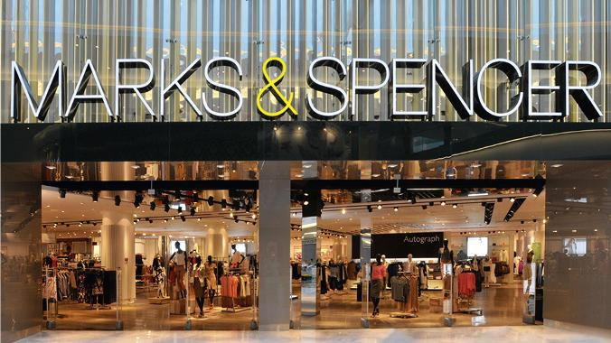[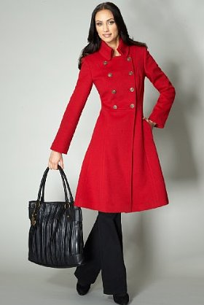](http://www.google.si/url?sa=i&rct=j&q=&esrc=s&source=images&cd=&cad=rja&uact=8&ved=0CAcQjRw&url=http://www.stylehive.com/bookmark/per-una-speziale-wool-rich-double-breasted-coat-marks-spencer-818888&ei=ISJRVaXNLYPoywPT-ICIDw&psig=AFQjCNGXgQkwIqY1Kxr4Sm4bPbw0NAeppQ&ust=1431466912542327)